CHAPTER ONE
INTRODUCTION
1.0 Background of the Study
Agriculture plays a major role in the economic development of many developing countries including Tanzania [1]. Crop productivity depends largely on soil fertility and proper soil management. One of the key indicators of soil fertility is soil pH, which determines the availability of nutrients to plants [2], [3]. Soil pH affects biological and chemical processes in the soil and influences crop growth and yield [3]. When soil pH is too acidic or too alkaline, essential nutrients become unavailable to crops, leading to poor plant performance. Many small-scale farmers do not regularly test their soil due to high costs and limited access to laboratories [4]. Recent advancements in sensor technology and smart agriculture have made it possible to develop low-cost soil monitoring systems [5], [12]. Smart systems that integrate sensors with data processing and mapping tools can help farmers understand soil conditions and make informed decisions [11], [14]. Therefore, a soil pH tracer with smart crop mapping can provide real-time soil pH measurement and recommend suitable crops based on soil condition [9], [21].

1.1 Problem Statement
Low agricultural productivity remains a challenge in many rural areas due to lack of accurate soil information [1], [4]. Farmers often select crops without knowing whether the soil pH is suitable, which results in low yields and crop failure [2]. Traditional soil testing methods are time consuming, expensive, and not easily accessible to small scale farmers [4]. Although some digital agricultural tools exist, many are costly or difficult to use [6], [18]. There is therefore a need for a simple, affordable, and smart system that traces soil pH and provides crop mapping to support farmers in making better agricultural decisions.

1.2 Objectives of the Study
1.2.1 Main Objective
To design and develop a soil pH tracer with smart crop mapping based on the measured values.
1.2.2 Specific Objectives
- To design a sensor-based system that detects real-time soil pH.
- To create a crop mapping database linked to specific pH ranges.
- To develop a simple user interface for result observation
1.3 Significance of the Study
i. Helping farmers determine soil pH and select suitable crops [2], [21]
Soil pH directly affects nutrient availability and crop growth. Farmers often rely on guesswork or expensive laboratory tests to know their soil’s pH. This system allows them too quickly and accurately measure soil pH on-site, ensuring they plant crops compatible with their soil conditions. By matching crops to suitable soil types, farmers can maximize yields and reduce the risk of crop failure.
ii. Improving agricultural productivity and reducing losses [1], [15]
Poor crop selection due to inadequate soil knowledge leads to stunted growth, low yields, or total crop failure. With timely and accurate soil pH information, farmers can choose the best crops for their land, increasing productivity. Higher yields translate to better income and food security while minimizing losses caused by unsuitable crop cultivation.
iii. Supporting sustainable farming and minimizing environmental pollution [3], [14]
Overuse or misuse of fertilizers is common when farmers are unsure about soil conditions. Excess fertilizer can harm the environment, causing water pollution and soil degradation. By providing precise soil pH data, this system helps farmers apply only the necessary amount of fertilizers, promoting sustainable farming practices and reducing harmful environmental impacts.
iv. Contributing to smart agriculture and providing reference material for future research [11], [20]
Smart agriculture uses technology to optimize farming decisions. This project integrates sensors, data analysis, and crop mapping, adding to the body of knowledge in smart agriculture. Future researchers can use this study as a reference for developing more advanced soil monitoring tools, automated decision systems, or precision farming methods, fostering technological growth in agriculture.

1.4 Scope of the Study
The study focuses on designing and implementing a soil pH tracer integrated with smart crop mapping. The system will measure soil pH, process the data, and display recommended crops based on measured pH value [7], [9].
The project does not include full soil nutrient analysis such as nitrogen, phosphorus, and potassium. It concentrates only on soil pH measurement and crop recommendation.

1.5 Chapter Summary
This chapter has introduced the study by presenting the background of the research, explaining the problem of lack of soil pH information among farmers, and stating the objectives of developing a soil pH tracer with smart crop mapping system. The significance and scope of the study were also discussed, showing how the system will benefit farmers, researchers, and the agricultural sector.
Overall, this chapter established the foundation of the study and justified the need for a smart solution to improve crop selection and agricultural productivity. The next chapter presents a review of related literature.

CHAPTER TWO
LITERATURE REVIEW
2.1 Introduction
This chapter reviews literature related to soil pH measurement, smart agriculture, IoT-based monitoring, and crop recommendation technologies [5], [12], [14]. The review helps to understand existing methods and identify gaps addressed by this study.
2.2 Empirical Review
Several empirical studies have demonstrated the importance of using sensor-based and IoT technologies in monitoring soil conditions and improving agricultural productivity.
Zhang et al. (2020) developed an IoT-based soil monitoring system that measures soil pH, moisture, and temperature in real time using sensors connected to a microcontroller [5]. Their system allowed farmers to remotely access soil data through a network platform. The results showed that real-time monitoring improves decision-making and reduces the need for manual soil testing, however this system is not affordable to local famers due to its cost.
Patel and Shah (2019) designed an IoT-based smart farming system that collects environmental and soil data to support farm management [6]. Their study found that automation of data collection reduces human effort and increases efficiency in farming operations. However, their system mainly focused on monitoring and did not include crop recommendation based on soil pH.
Kumar et al. (2021) developed a smart agriculture monitoring system using sensors and a web-based interface [7]. The system displayed soil parameters and provided general crop information. Their findings indicated that farmers can easily access real-time soil data using mobile devices, but the system lacked intelligent mapping and personalized crop recommendation.
Ayaz et al. (2019) investigated the use of IoT technologies in smart agriculture and concluded that IoT-based systems improve productivity, reduce water wastage, and support sustainable farming [12]. Their study emphasized the importance of integrating sensors, communication networks, and data analytics.
Brady and Weil (2017) explained through experimental soil studies that soil pH directly affects nutrient availability and plant growth [2]. Their findings showed that crops perform best when grown within their optimal pH range.
Havlin et al. (2018) also reported that improper soil pH leads to nutrient imbalance and reduced crop yield [3]. They recommended regular soil testing and proper soil management practices.
Overall, these empirical studies confirm that sensor-based soil monitoring is effective and beneficial. However, most of the reviewed systems focus on data collection and monitoring only. This gap justifies the need for the proposed system.

2.3 Related Works
FAO reported that digital technologies are increasingly being adopted to improve agricultural productivity and food security [1].
World Bank highlighted that digital agriculture solutions help farmers make informed decisions, but affordability remains a major challenge for small-scale farmers in developing countries [4].
Wolfert et al. reviewed big data applications in smart farming and showed that data-driven agriculture improves efficiency and sustainability [14].
Bacco et al. presented an overview of IoT-based smart agriculture systems and emphasized the need for simple and low-cost solutions [20].
Rayhana et al. developed an IoT-based greenhouse monitoring system that controls environmental conditions, but the system does not provide crop recommendation based on soil pH [13].

2.4 Research Gap
From the reviewed empirical studies and related works, it is evident that many existing systems focus on soil parameter monitoring and data display and other system measures soil pH [5], [6], [7].
Furthermore, most existing solutions are either expensive or complex for small-scale farmers in developing countries. Therefore, there is a need for a low-cost, user-friendly system that traces soil pH and provides smart crop mapping to guide farmers in selecting suitable crops and improving agricultural productivity [4], [18].

2.5 Chapter Summary
This chapter presented a comprehensive review of literature related to soil pH measurement, smart agriculture, IoT-based monitoring, and crop recommendation systems. The empirical review highlighted studies that implemented sensor-based soil monitoring and demonstrated the effectiveness of IoT technologies in improving farm management and decision-making [2]–[12].
The related works section discussed existing digital agriculture systems and smart farming solutions, emphasizing their strengths and limitations [1], [4], [13]–[20].
Finally, the research gap was identified, showing that while many systems monitor soil parameters and measuring soil pH. This gap justifies the development of the proposed soil pH tracer with smart crop mapping system.

CHAPTER THREE
METHODOLOGY
3.0 Introduction
This chapter outlines the methodology adopted for the design, development, and evaluation of a smart soil pH tracer integrated with crop mapping. The methodology provides a structured framework for collecting, analyzing, and interpreting soil pH data and for generating crop recommendations suitable for different soil types. This chapter discusses the research approach, project methods, and study area, ethical considerations, study timeline, budget, and concludes with a chapter summary. The purpose is to ensure that the study is replicable, reliable, and applicable to improving agricultural productivity. Fig. 1 show overall system flow of soil pH measurement and crop mapping.
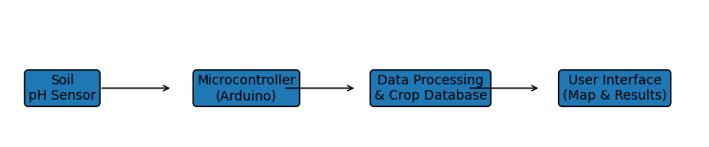
Fig. 1. Figure showing Soil pH tracer system

3.1 Research Approach
The study adopts a practical and applied research approach combining experimental and descriptive research methods. The experimental aspect focuses on the design, calibration, and testing of the smart soil pH tracer to ensure accurate measurement of soil acidity. The descriptive aspect involves mapping the soil pH distribution across the study area and recommending suitable crops based on the observed soil conditions. The integrated approach enables the collection of empirical data while simultaneously applying it to generate meaningful insights for farmers, contributing to enhanced decision-making in crop selection and soil management.

3.2 Project Methods
This section explains the methods, tools, and techniques used to achieve the study objectives.
3.2.1 Data Collection Methods
Soil Sampling: Soil samples will be collected from multiple farms within Iringa municipal using a smart soil pH tracer.
Sensor Measurements: The smart tracer will measure soil pH values in real-time, storing the data in an IoT-enabled device for further analysis.
Observation: Field observation will be conducted to validate sensor readings and understand local farming practices.
3.2.2 Tools and Equipment
The project will use both hardware and software methods.
Hardware Tools:
- pH sensor:This device is used to measure the acidity or alkalinity of the soil. In this project, it collects soil pH data from different farm areas. This data helps in identifying soil conditions and forms the basis for smart crop mapping.
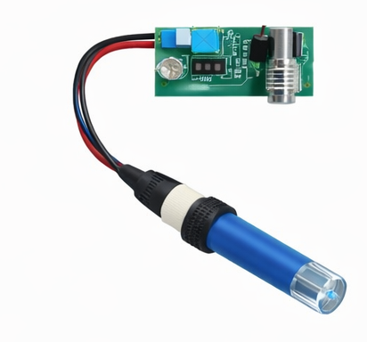
Fig. 2. Figure showing pH sensor
- Microcontroller (Arduino): This device acts as the brain of the system. It receives soil pH readings from the sensor, processes the data, and determines the soil category (acidic, neutral, or alkaline). It supports decision-making for suitable crop selection.

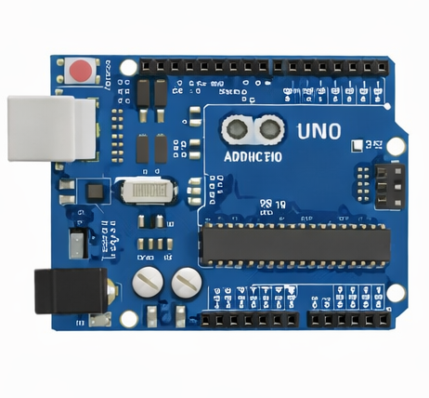
Fig. 3. Figure showing Microcontroller (Arduino)

- LCD display: This device shows real-time soil pH values. It allows farmers or users to easily monitor soil conditions directly in the field, enabling quick agricultural decisions.
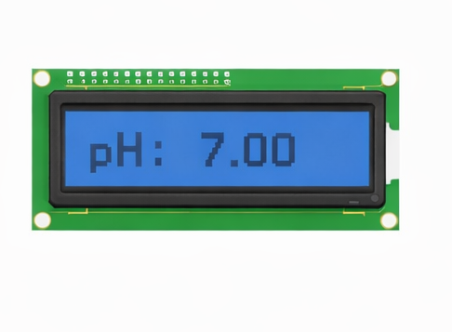
Fig. 4. Figure showing LCD display
- Power supply: This device provides electrical energy to operate the system. It ensures stable and continuous functioning of the soil pH tracer during field use.
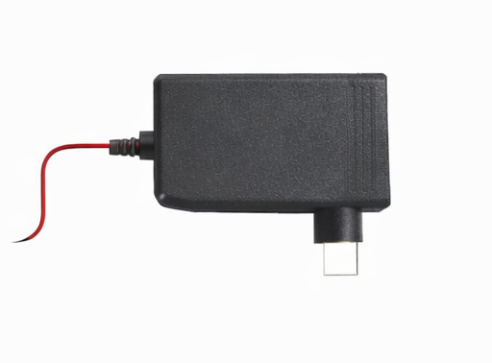
Fig. 5. Figure showing power supply
- Connecting wires: These link all components together. They allow signal and power transmission between the sensor, Arduino, and display, ensuring accurate and reliable system performance.
Software Tools:
- Arduino IDE
- Database (MySQL)
- Programming language (C++ and Python)
- Mobile interface
Techniques Used:
- Sensor data acquisition
- Data processing and storage
- Crop recommendation algorithm
- System testing and validation
3.3 Area of the Study
The study will be conducted in Iringa municipal, selected due to its easy to access and famers experience challenges related to soil fertility and crop selection. The geographical location provides varying soil conditions, which are ideal for testing the smart soil pH tracer and generating accurate crop mapping recommendations. The study area includes smallholder farms, allowing for practical application of the developed system.

3.4 Ethical Considerations
Ethical principles are observed through the study to ensure responsible conduct of research. The study will observe the following ethical guidelines:
Consent: Permission will be obtained from farmers before collecting soil samples from their land.
Confidentiality: Data collected will be used exclusively for research purposes and will remain confidential.
Environmental Safety: Soil sampling will be conducted with minimal disruption to the environment.
Integrity: All data will be accurately reported, ensuring honesty in research findings.
3.5 Study Timeline
The study activities will be organized into a structured timeline to ensure timely completion. The schedule of activities is summarized in the table below:
No. | Activity | Duration (Weeks)
1. | Literature review | 2
2. | Device design & calibration | 4
3. | Field data collection | 3
4. | Data analysis | 2
5. | Report writing & submission | 3
Total |  | 14

3.6 Study Budget
The estimated budget for the study is presented in the table below:
No. | Item | Quantity | Unit Cost (Tsh) | Total Cost (Tsh)
1. | pH Sensor | 1 | 50,000/= | 50,000/=
2. | Microcontroller | 1 | 40,000/= | 40,000/=
3. | LCD Display | 1 | 30,000/= | 30,000/=
4. | Wires & Components | 1 set | 20,000/= | 20,000/=
5. | Power Supply | 1 | 25,000/= | 25,000/=
6. | Printing & Binding | - | 30,000/= | 30,000/=
Total |  |  |  | 195,000/=

3.7 Chapter Summary
This chapter has outlined the methodology for the study, including the research approach, project methods, study area, ethical considerations, timeline, and budget. The study combines experimental testing of a smart soil pH tracer with descriptive mapping of soil conditions to recommend suitable crops. The methodology ensures that the study is systematic, replicable, and ethically conducted, providing reliable data to improve agricultural productivity and promote sustainable farming practices.

REFERENCES
[1] FAO, The State of Food and Agriculture. Rome, Italy: Food and Agriculture Organization, 2020.
[2] N. C. Brady and R. R. Weil, The Nature and Properties of Soils, 15th ed. Pearson Education, 2017.
[3] J. L. Havlin, S. L. Tisdale, W. L. Nelson, and J. D. Beaton, Soil Fertility and Fertilizers: An Introduction to Nutrient Management, 8th ed. Pearson, 2018.
[4] World Bank, Transforming Agriculture for Sustainable Growth. Washington, DC, USA: World Bank Publications, 2021.
[5] Y. Zhang, G. Wang, and J. Wang, “Design of soil monitoring system based on IoT,” Sensors, vol. 20, no. 15, pp. 1–15, 2020.
[6] N. Patel and D. Shah, “IoT based smart farming system,” International Journal of Computer Applications, vol. 176, no. 35, pp. 1–5, 2019.
[7] R. Kumar, M. Singh, and P. Gupta, “Smart agriculture monitoring system using IoT,” International Journal of Engineering Research and Technology, vol. 10, no. 3, pp. 450–456, 2021.
[8] ISO/IEC, ISO/IEC 25010: Systems and Software Quality Models. Geneva, Switzerland, 2019.
[9] A. K. Tripathy, J. Adinarayana, and D. Sudhakar, “Crop recommendation system using machine learning,” International Journal of Computer Applications, vol. 182, no. 3, pp. 25–29, 2018.
[10] S. R. Kale and S. J. Patil, “Smart farming using wireless sensor networks,” International Journal of Advanced Research in Computer Engineering & Technology, vol. 6, no. 4, pp. 498–502, 2017.
[11] A. Kamilaris, A. Kartakoullis, and F. Prenafeta-Boldú, “A review on the practice of big data analysis in agriculture,” Computers and Electronics in Agriculture, vol. 143, pp. 23–37, 2017.
[12] M. Ayaz, M. Ammad-Uddin, Z. Sharif, A. Mansour, and E.-H. Aggoune, “Internet-of-Things based smart agriculture: Toward making the fields talk,” IEEE Access, vol. 7, pp. 129551–129583, 2019.
[13] R. Rayhana, G. Xiao, and Z. Liu, “Internet of Things empowered smart greenhouse,” IEEE Journal of Radio Frequency Identification, vol. 2, no. 4, pp. 195–211, 2018.
[14] A. Wolfert, L. Ge, C. Verdouw, and M. Bogaardt, “Big data in smart farming – A review,” Agricultural Systems, vol. 153, pp. 69–80, 2017.
[15] P. S. Thenmozhi and K. Rajeswari, “Crop yield prediction using machine learning,” International Journal of Engineering and Advanced Technology, vol. 8, no. 6, pp. 1–6, 2019.
[16] D. Ramesh and B. Vishnu Vardhan, “Analysis of crop yield prediction using data mining techniques,” International Journal of Research in Engineering and Technology, vol. 4, no. 1, pp. 47–52, 2015.
[17] R. K. Ranjan, S. Verma, and A. K. Srivastava, “Smart agriculture using sensor-based IoT system,” International Journal of Innovative Technology and Exploring Engineering, vol. 8, no. 10, pp. 724–728, 2019.
[18] S. Mekala and P. Viswanathan, “A survey: Smart agriculture IoT with cloud computing,” International Journal of Innovative Research in Computer and Communication Engineering, vol. 5, no. 2, pp. 195–201, 2017.
[19] M. T. Lazarescu, “Design of a WSN platform for long-term environmental monitoring,” IEEE Transactions on Instrumentation and Measurement, vol. 62, no. 4, pp. 908–915, 2013.
[20] A. Bacco, M. Ferro, A. Gotta, M. Marchese, and F. Patrone, “IoT-based smart agriculture: An overview,” Future Internet, vol. 11, no. 2, pp. 1–22, 2019.
[21] S. Priya, D. Praveen, and S. K. Singh, “Soil nutrient analysis and crop recommendation system,” International Journal of Scientific Research in Computer Science, vol. 6, no. 3, pp. 50–55, 2021.
[22] R. S. Kumar and P. Rajalakshmi, “Precision agriculture using IoT and machine learning,” International Journal of Engineering and Technology, vol. 7, no. 2, pp. 129–134, 2018.

